Leadership Identity Mini-Exercise
Step 1: Explore
Review the sample leadership identity phrases below. Circle or highlight any that resonate with how you want to show up as a leader.
People-Centered

- People First Leader
- Trust Builder
- Growth Catalyst
- Bridge Builder
- Team Champion
- Servant Leader
Vision & Strategy

- Purpose-Driven Visionary
- Strategy Shaper
- Future Builder
- Bold Pathfinder
- Culture Architect
- Change Maker

Results & Performance

- Results Driven Innovator
- Execution Specialist
- Impact Creator
- Performance Catalyst
- Outcome Oriented
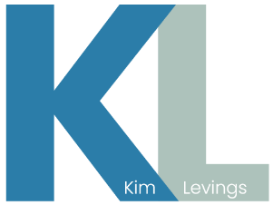
- Efficiency Driver

Character & Integrity

- Integrity Anchor
- Courageous Voice
- Authentic Leader
- Humble Servant
- Values Guardian
- Truth Teller

Step 2: Refine
Choose your top 3 phrases and write them down.
Now, combine or adjust them into one unique statement that feels true to you.
For example:
- “People First Leader” + “Bold Pathfinder” = “People-Centered Pathfinder.”
- “Integrity Anchor” + “Impact Creator” = “Integrity-Driven Impact.”

Step 3: Anchor
Ask yourself: “If I lived this leadership identity daily, what one behavior would change immediately?” Write down one small action you’ll take this week to embody it.

